**Task 2 – Video Game Sales**

**Introduction**

The world of video games has evolved into a global entertainment industry, captivating players of all ages and backgrounds. Video game sales have become a key indicator of the industry's health and a source of valuable insights for game developers, publishers, and enthusiasts alike. The Video Game Sales dataset provides a treasure trove of information about video game titles, their sales figures, genres, platforms, and release dates.

**EDA Process**

Exploratory Data Analysis (EDA) is a foundational process in data analysis and statistics. It is the initial step in understanding and gaining insights from a dataset. EDA involves systematically examining data using various statistical and visualization techniques to identify patterns, relationships, anomalies, and trends within the data.

* Step 1: In the first step we checked the data frame for null values

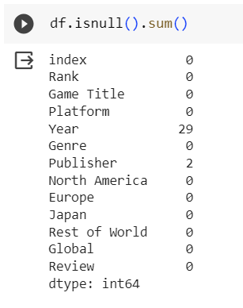

* Step 2: The columns (year, publisher) have a small number of null values, so we drop those rows.

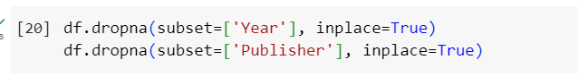

* Step 3: Now we find which video game achieved the highest number of sales

To find which video game achieved the highest number of sales we use a bar chart for data visualization

